BANKING SYSTEM GUI APPLICATION TESTING
The main objective is to check the complete integration of all the banking system components by testing end to end user workflows, from the GUI interaction through controller logic, business model processing and final data persistence in text files.
1.Customer Registration and Account Creation
The bank teller begins by logging into the system and registering a new customer. The customer details are saved in the customers.txt file. The bank teller then proceeds to create an account for the customer by first searching for the customer to ensure the customer record exists.
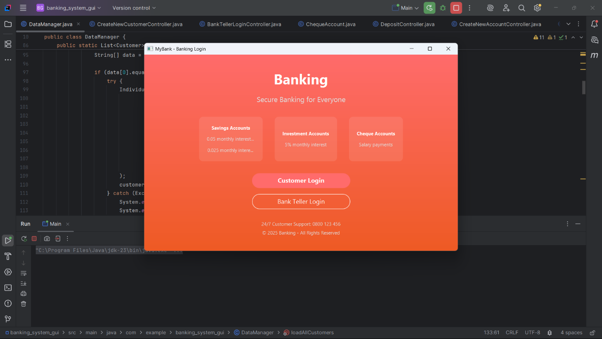
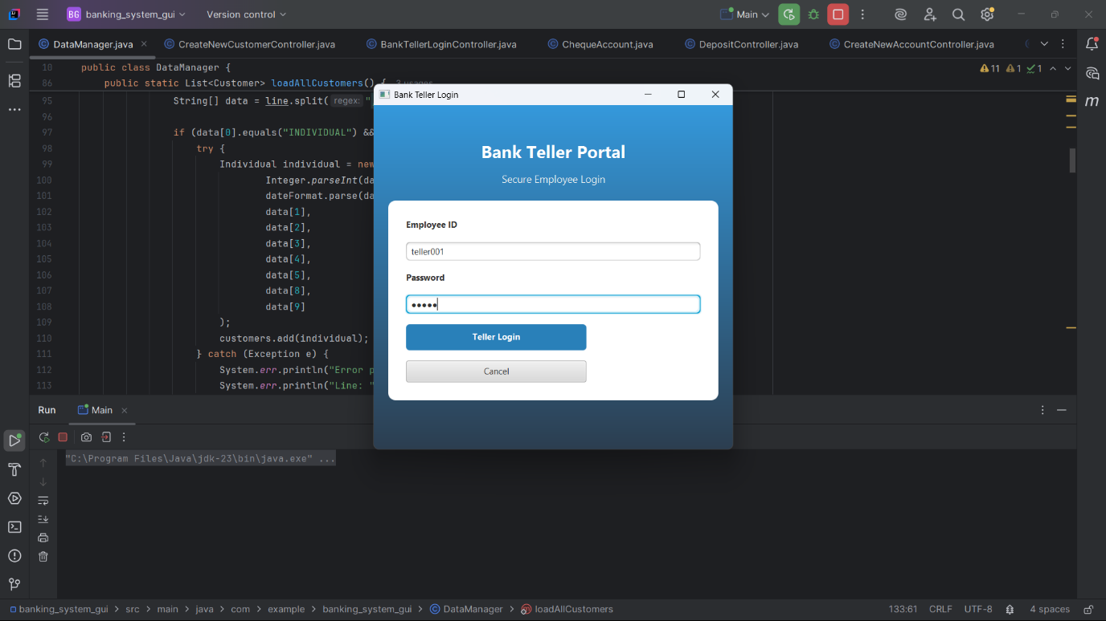

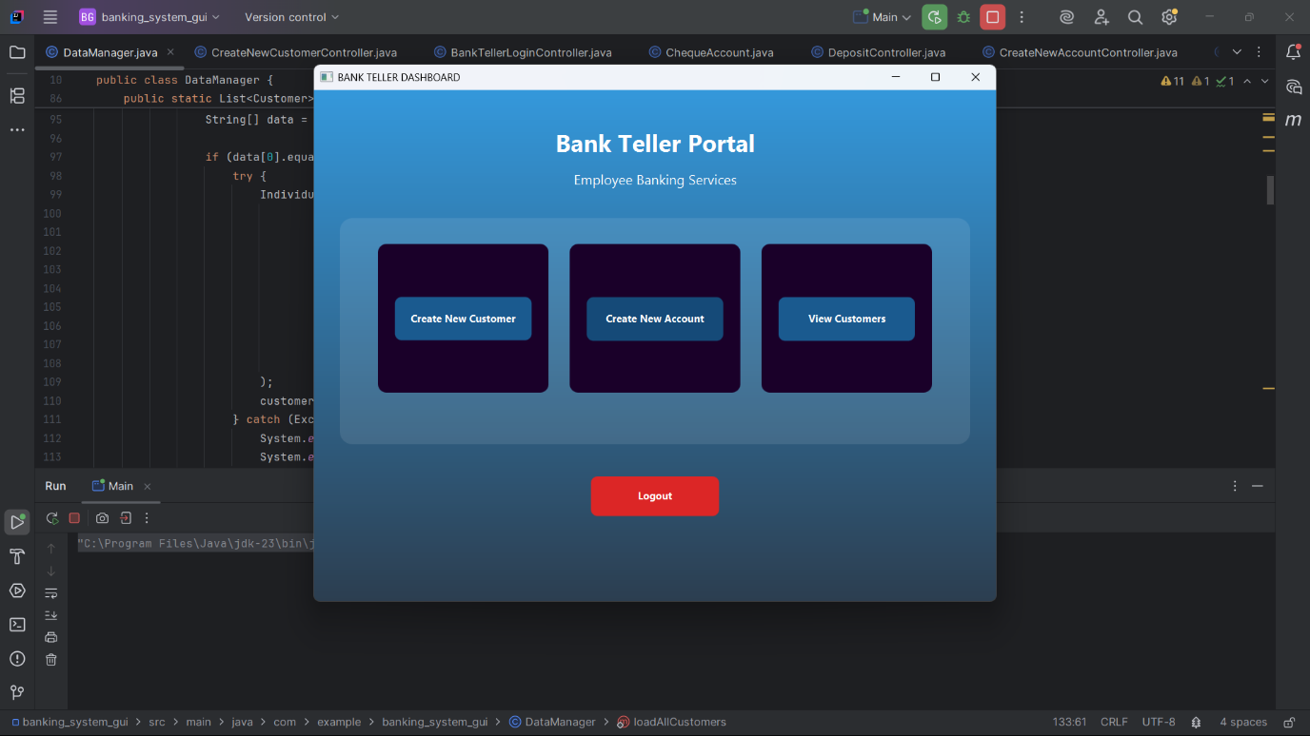

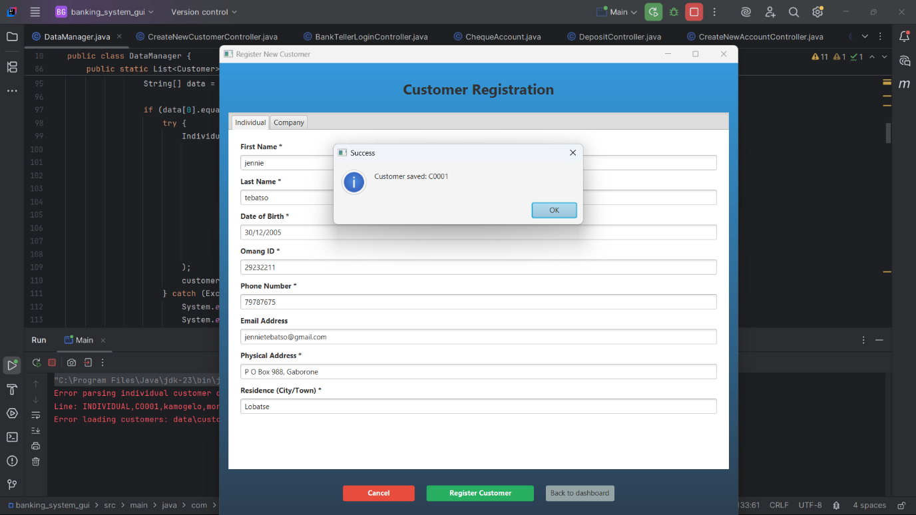

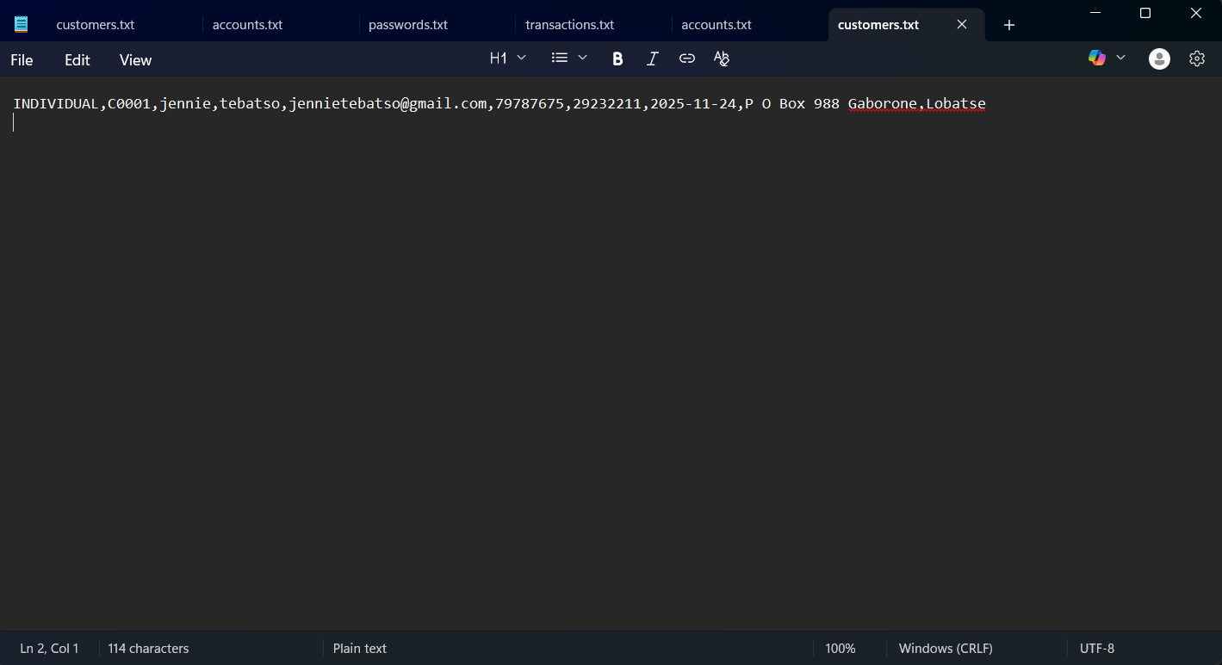

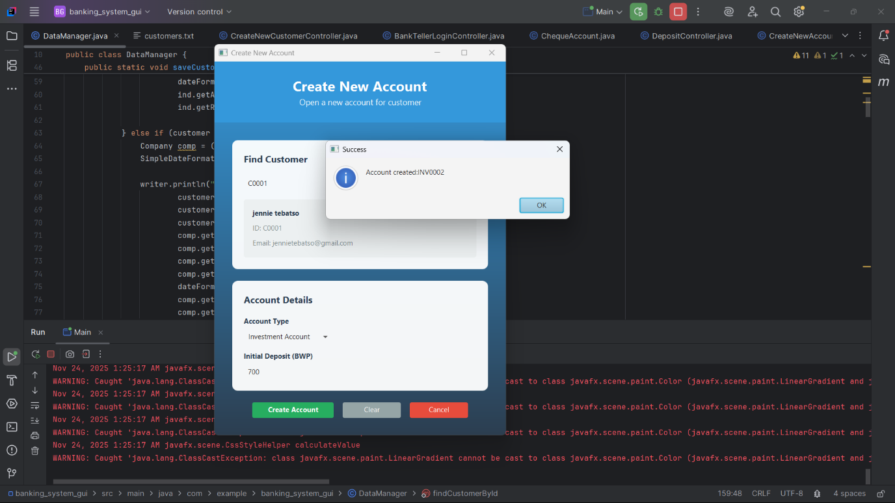

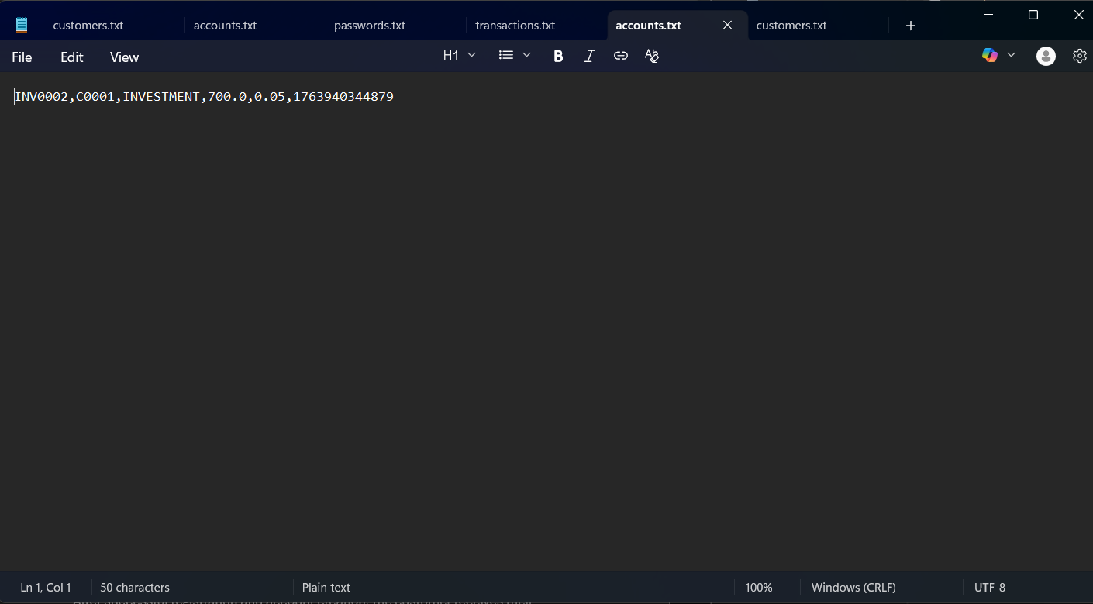

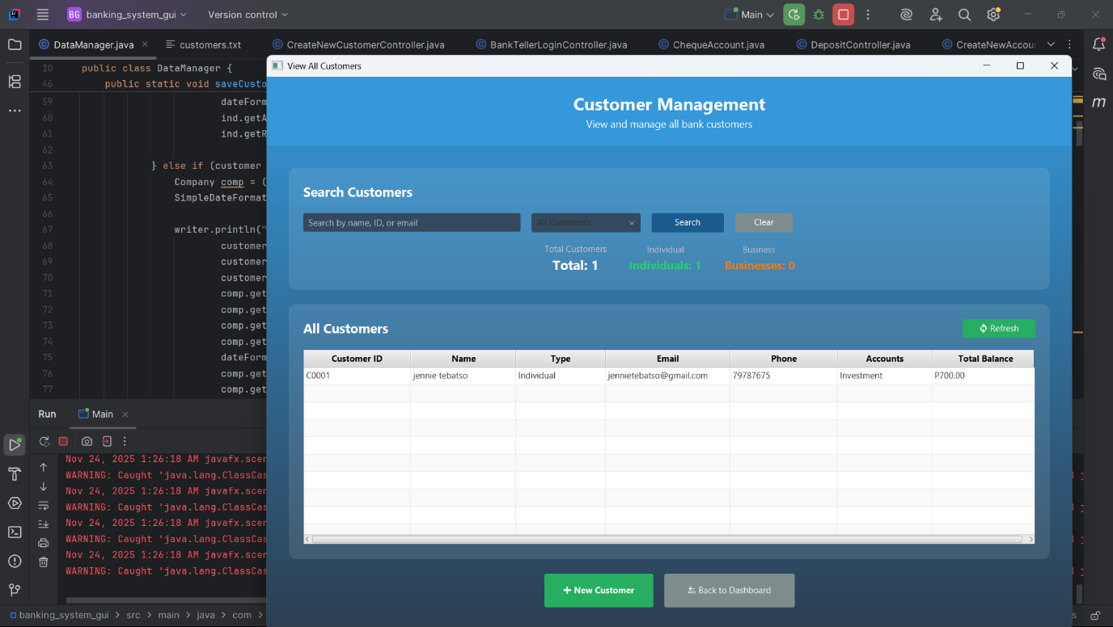
2. Customer login and performs main operations
After successful registration and account creation, the customer receives their customer ID and creates a password to enable login access. The customer enters their username and password in the Login View and, upon successful authentication, lands on the customer dashboard.
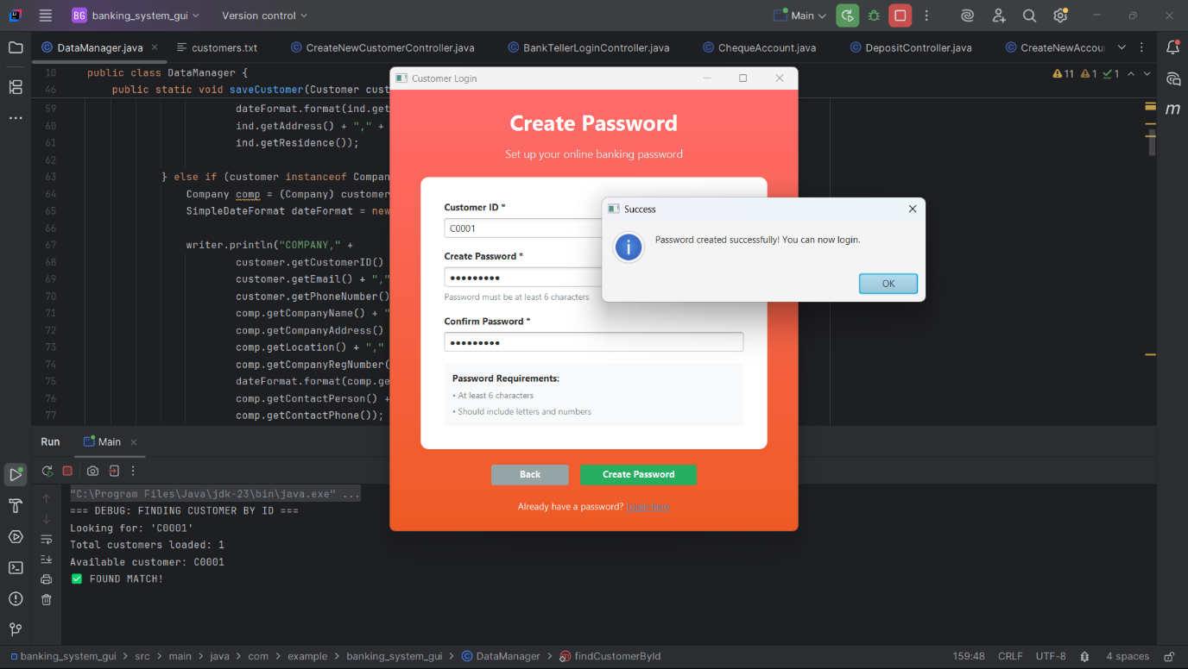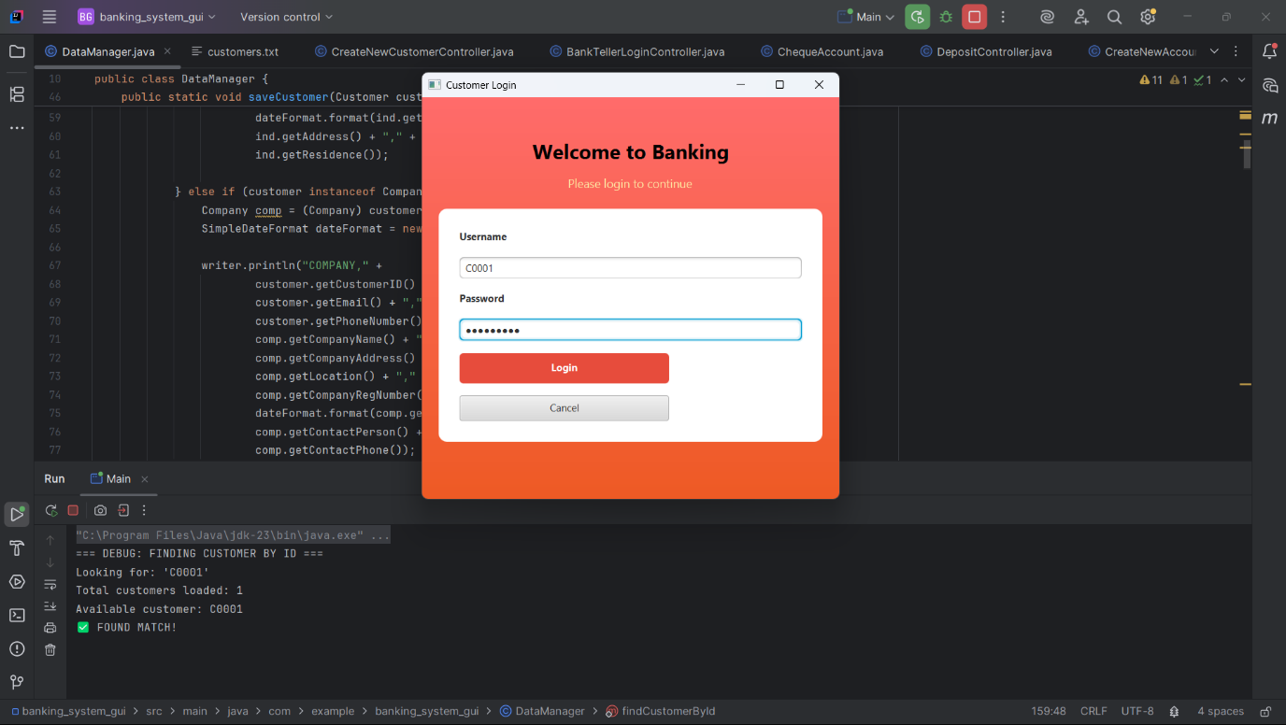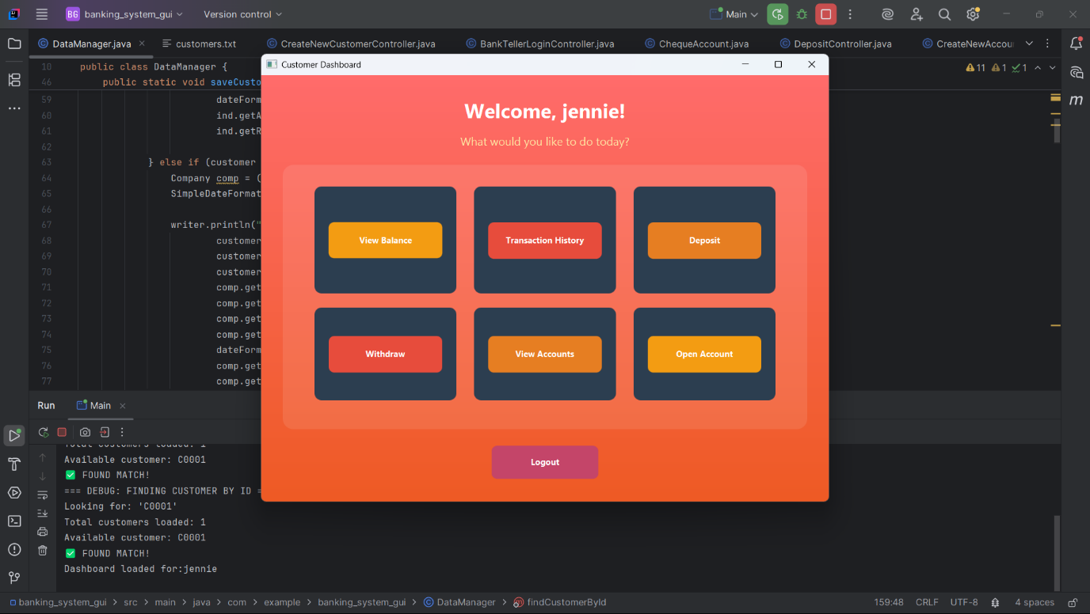
3. Transactions flow
After successful login, the customer can perform various banking operations including depositing funds into existing accounts, withdrawing funds, viewing balances, viewing account details, reviewing transaction history, and opening additional accounts.
